Program: 1 Finding factorial of number

**package** loops;

**import** java.util.Scanner;

**public** **class** Factorial {

**public** **static** **void** main(String[] args) {

Scanner sc = **new** Scanner(System.***in***);

// **TODO** Auto-generated method stub

**int** n = sc.nextInt();

**int** factorial = 1;

**for** (**int** i = n; i >=1; i=i-1)

factorial = factorial*i;

System.***out***.println(factorial);

}

}

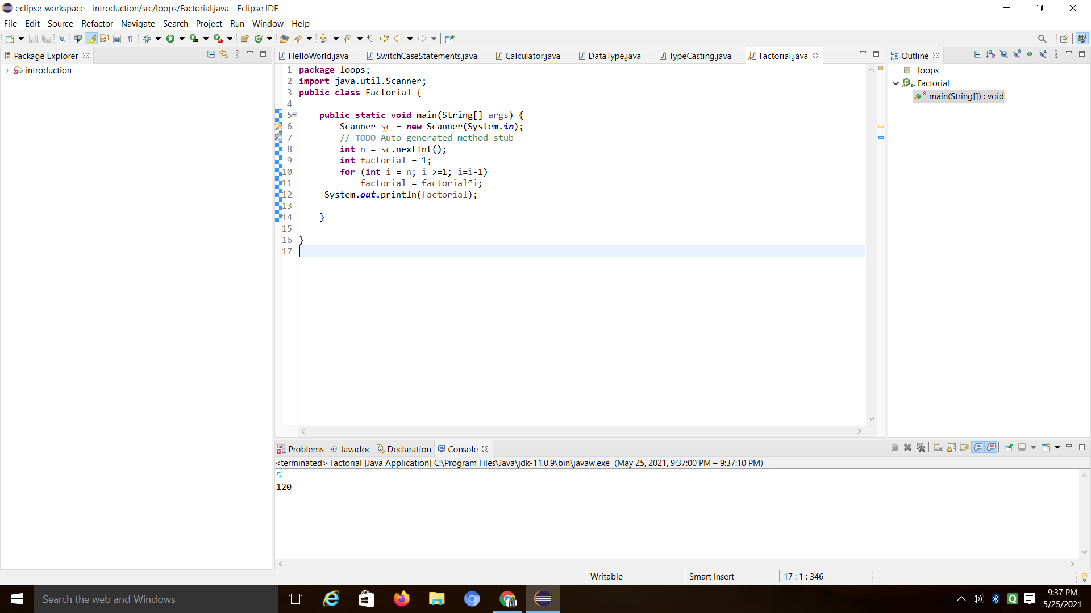

Program 2: write Fibonacci series

**package** fibonacciSeries;

**class** Fiboseries{

**public** **static** **void** main(String[] args) {

**int** n = 10, firstTerm = 0, secondTerm = 1;

System.***out***.println("Fibonacci Series till " + n + " terms:");

**for** (**int** i = 1; i <= n; ++i) {

System.***out***.print(firstTerm + ", ");

// compute the next term

**int** nextTerm = firstTerm + secondTerm;

firstTerm = secondTerm;

secondTerm = nextTerm;

}

}

}

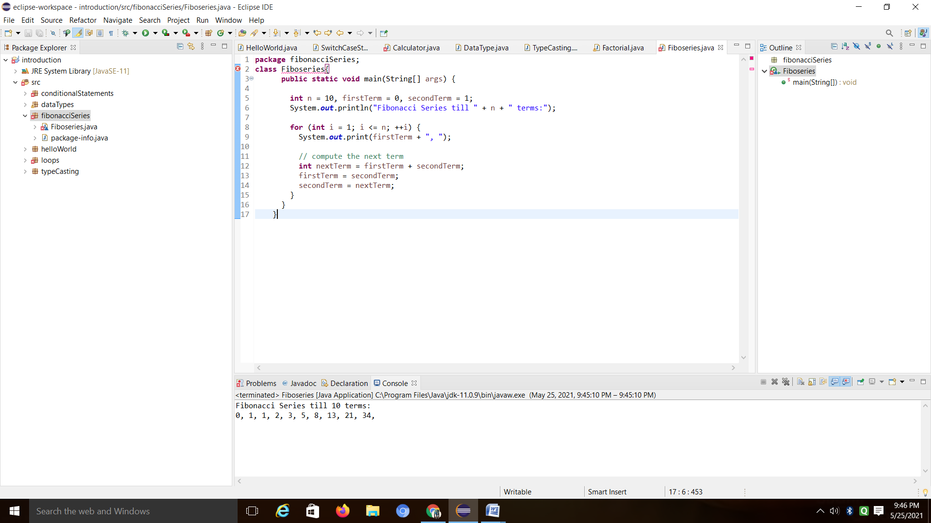

Program 3: Given number is prime number

**package** primeNumber;

**public** **class** PrimeNumber{

**public** **static** **void** main(String[] args) {

**int** num = 29;

**boolean** flag = **false**;

**for** (**int** i = 2; i <= num / 2; ++i) {

// condition for nonprime number

**if** (num % i == 0) {

flag = **true**;

**break**;

}

}

**if** (!flag)

System.***out***.println(num + " is a prime number.");

**else**

System.***out***.println(num + " is not a prime number.");

}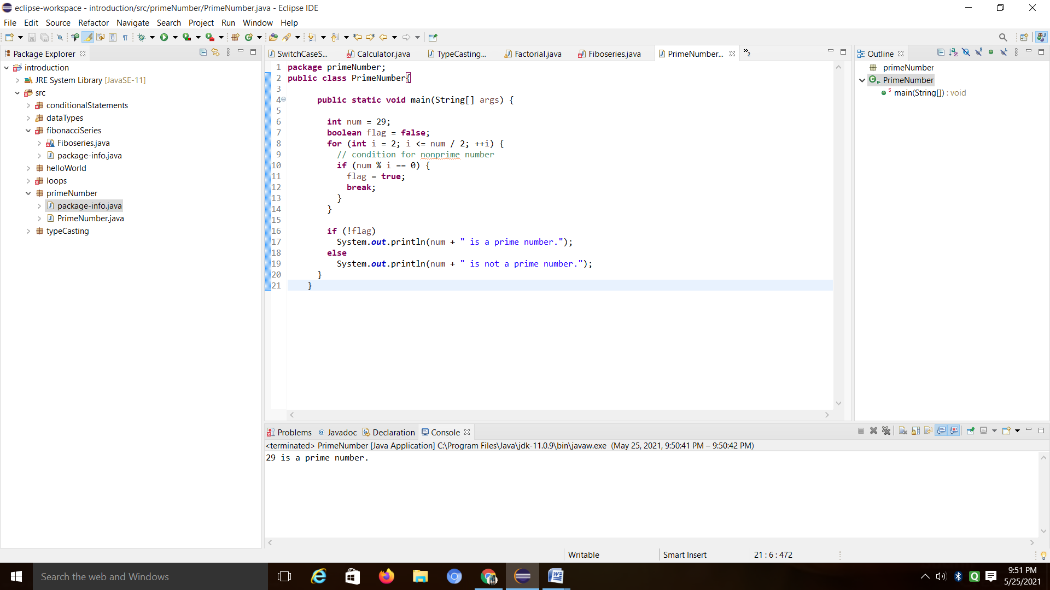

}

Program 4: Reverse the number

**package** reverseNumber;

**class** ReverseNumber {

**public** **static** **void** main(String[] args) {

**int** num = 1234, reversed = 0;

**while**(num != 0) {

**int** digit = num % 10;

reversed = reversed * 10 + digit;

num /= 10;

}

System.***out***.println("Reversed Number: " + reversed);

}

}

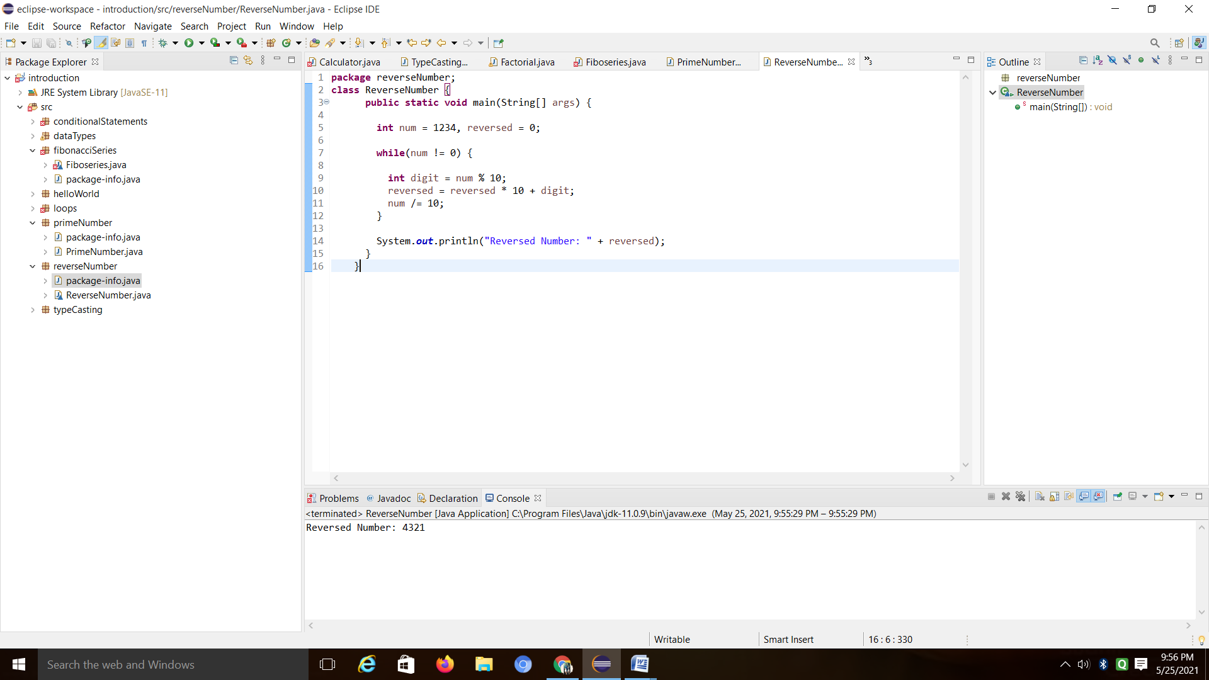

Program 5: typecasting

**package** typeCasting;

**public** **class** TypeCasting {

**public** **static** **void** main(String[] args) {

//automatictypecasting

//short x = 4;

//float y = x;

//System.out.println(y);

//manualtypecasting

**float** x = 4;

**short** y = (**short**)x;

System.***out***.println(y);

System.***out***.println(x);

}

}

